Let’s begin with a few….
Cautionary Tales
Perfesser Plum
“…and you’ll know the truth, and the truth will set you free.”
[John 8:32]
Yeah, well, maybe.
Cautionary Tale 1. Galileo (“Seeing is believing.”) versus The Church (“Believing is seeing.”)
Think about that. You get it? Okay, what’s it mean?
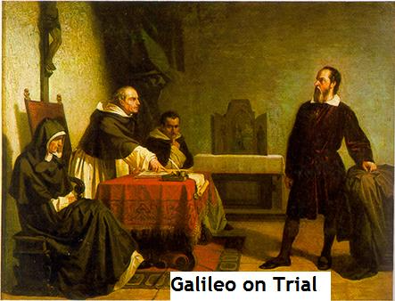
Galileo to Kepler, 1610
“My dear Kepler,” says Galileo, “what would you say of the learned here, who, replete with the pertinacity of the asp, have
steadfastly refused to cast a glance through the telescope?”
“Just look through the telescope. You’ll SEE that I’m right!”
“NO! We already KNOW that you’re wrong.”
“For Pete’s sake, LOOOOOK!”
“NO!”
“What shall we make of this?,” Galileo asks Kepler. “Shall we laugh, or shall we cry?”
http://www.law.umkc.edu/faculty/projects/ftrials/galileo/galileo.html
Copernicus theorized that the sun was the center of the universe and that the earth revolved around the sun. Galileo tested the Copernican theory with data collected through his telescope. Sure enough, Copernicus was right. Galileo published his data. This got him in trouble with the Church, whose doctrine was that the earth----not the sun----was the center of the universe. So, they put Galileo on trial. They found Galileo guilty.
“The proposition that the Earth isn’t the center of the world and immovable but that it moves, and also with a diurnal motion, is equally absurd and false philosophically and theologically considered at least erroneous in faith.”
They sentenced Galileo to prison.
“We condemn you to the formal prison of this Holy office during our pleasure, and by way of salutary penance we enjoin that for three years to come you repeat once a week at the seven penitential Psalms. Reserving to ourselves liberty to moderate, commute or take off, in whole or in part, the aforesaid penalties and penance.
And so we say, pronounce, sentence, declare, ordain, and reserve in this and in any other better way and form which we can and may rightfully employ.”
Galileo was eventually vindicated. But first he died. The excesses of the Church (suppression of individual research, thinking, and speech; intransigence in the face of contradicting facts) helped to bring in the Reformation---which was not a total blessing. But Galileo’s ideas (and empirical methods) won.
What does Galileo’s trial have to do with education?
Some persons in this field are empiricists---but there are not necessarily so radically empirical that they believe we can know NOTHING except through experience. See also Roger Bacon here and here; and Francis Bacon, on inductive reasoning and on the “idols” that distort knowledge of the truth. Like Galileo, modern day empiricists follow the facts---the data. Either (1) facts lead them to develop beliefs (“Okay, so I think it works like this….”) or (2) they use facts to TEST beliefs (“Let’s collect data to see if our hypothesis [beliefs] are wrong.”).
However, many persons and groups in education (anti-empiricists) search for facts that support what they already believe. You can always find support. Interview enough persons and someone will agree with you.
“Adolph Hitler was a kind person.”
“Are you insane?”
“Well, he was nice to kids and to his dogs. A person who is not nice would not be kind to kids and to his dog. So, there.”
It’s called “cherry picking.” The point is, How much evidence is AGAINST the hypothesis or claim? Is mass murder consistent with the definition of “nice person”? You are not trying to SUPPORT your hypothesis or claim. You are TESTING it. Which means searching for evidence that FALSIFIES it. If you can’t find any evidence that falsifies your hypothesis or claim, it does NOT mean that you hypothesis or claim is TRUE. It simply means that it is not false---so far. But we will keep looking---especially when the consequences of thinking you are right when in fact you are wrong are seriously bad.
Anti-empiricists also ignore facts that contradict what they believe. Still other anti-empiricists collect no data at all. They know in their hearts that they are right.
"Phonics is incompatible with a whole language perspective on reading and therefore is rejected." [Watson, D. (1989). Defining & describing whole language. Elementary School Journal, 90, 129-142.] Sounds like the same illogic spoken by the prosecutors at Galileo’s trial.
"It seems futile to try to demonstrate superiority of one teaching method over another by empirical research." [Weaver, C. (1988). Reading: Progress and practice. p. 220. Portsmouth, NJ: Heinemann.] Is it really futile?
"Early in our miscue research, we concluded…That a story is easier to read than a page, a page easier to read than a paragraph, a paragraph easier than a sentence, a sentence easier than a word, and a word easier than a letter. Our research continues to support this conclusion and we believe it to be true…" Goodman, K. & Goodman, Y. (1981). It’s easy to do research in a way that supports what you believe? That’s why OTHER persons should test what you believe. It’s called “independent research.”
BEWARE of anti-empiricists. They will sell you a mirage.
The battle between empiricists and anti-empiricists in education has been fought a long time. The anti-empiricists in schools of education, in school districts, and in national curriculum organizations (such as National Council for Teachers of English) have had control for decades. That’s why there are so many untested and harmful fads---for example, in reading and math. But now, with state accountability systems, the pendulum may be swinging back to scientific reasoning---rather than unfounded belief, doctrine, and speculation---to make education decisions. [Of course, the accountants---in their zeal and self-interest---will go too far!] But the anti-empiricists are still around. Like zombies, they don’t die.

Here’s the lesson for persons who want to be leaders.
The truth WILL set YOU free----from error. But before it helps you to set other persons free, you’ll be condemned by those persons whose power (position, control, prestige, and privilege) requires unquestioned acceptance of their doctrine. For, if it’s shown that they’re wrong on one count, they may be wrong on other counts; therefore, they are fallible; therefore, they must be wrong about many things; therefore, they aren’t legitimate authorities and shouldn’t be trusted or obeyed.
But if you yield to dictates of the powerful, and to pressures from the herd of believers in order to avoid confrontation and to feel safe, you’ll become a coward. And persons (children, teachers, civilization) who depend on you for the truth and for your strength to defend THEM against the herd and the powerful, will be sacrificed on the altar of your fear. [Please click that link.]
If you assert the right to think for yourself---to be skeptical, to require credible data, to challenge the group mind and the dictates of persons in power---you may be ridiculed, threatened, and even lose your job. But if you persist, you may just win. And in the meantime, you’ll be serving something more important than your desire for temporary security (bought at the cost of your soul); namely, the truth and your moral obligation not to harm children. Besides, do you want to live on your knees?
Here’s what Justice Clarence Thomas has to say on the matter.
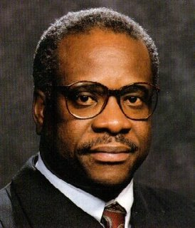
If you trim your sails, you appease those who lack the honesty and decency to disagree on the merits, but prefer to engage in personal attacks. A good argument diluted to avoid criticism isn’t nearly as good as the undiluted argument because we best arrive at truth through a process of honest and vigorous debate. Arguments shouldn’t sneak around in disguise, as if dissent were somehow sinister or clandestine. One shouldn’t be cowed by criticism.
In my humble opinion, those who come to engage in debates of consequence and who challenge accepted wisdom should expect to be treated badly. Nonetheless, they must stand undaunted. That is required. And that should be expected. For it is bravery that is required to secure freedom.
On matters of consequence, reasons and arguments must be of consequence. Therefore, those who choose to engage in such debates must themselves be of consequence. Much emphasis these days is placed on who has the quickest tongue and who looks best on television. There seems to be an obsession with how one looks to others; hence, a proliferation of public relations professionals and spin doctors. As I was counseled some years ago, perceptions are more important than reality. But this is madness. No car has ever crashed into a mirage. No imaginary army has ever invaded a country.
What makes it all worthwhile? What makes it worthwhile is something greater than all of us. There are those things that at one time we all accepted as more important than our comfort or our discomfort - if not our very lives: duty, honor, country. There was a time when all was to be set aside for these. The plow was left idle, the hearth without fire, the homestead abandoned.
http://americanradioworks.publicradio.org/features/sayitplain/cthomas.html
Cautionary Tale 2. Decisions based on Invalid Data
Iris Ledbetter, Principal at Eldorado Elementary, worked with teachers to select math materials that would raise achievement. They chose Holistic Math. Staff worked hard, but achievement didn’t rise. It fell. The materials were poorly designed. Sadly, neither Ms. Ledbetter nor the teachers knew how to examine the evaluation research base for Holistic Math---which would have shown that: (1) the researchers used such broad definitions of achievement that changes in NONmath behaviors (such as student “interest in math”) made the materials look good, even though the kids did poorly on many REAL math skills; and (2) the researchers didn’t control for, or even consider the effects of extraneous variables (such as maturation) that accounted for some of the alleged progress of children in their research. Result? Students at Eldorado got poor math instruction three years in a row. So, it was nearly impossible to succeed with middle school math. Nice work, Iris!
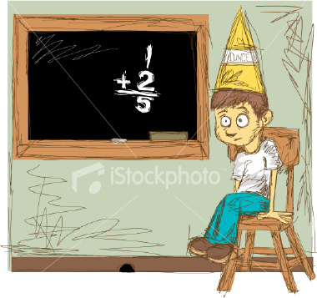
Cautionary Tale 3. Decisions Based on a Simplistic Picture of the Causal Process.
Jose’ Ramirez, Assistant Principal at Hoarse Coyote High School, planned and implemented remedial reading. He and his teachers examined the evaluation research bases for many remedial reading programs, and wisely selected the one with the most credible data showing effectiveness. Mr. Ramirez made sure that teachers in the remedial reading classes were trained to high proficiency and implemented the programs carefully. GREAT JOB, Mr. R.! Yet, student progress was minimal---far below what the research had led Mr. Ramirez to predict. Why? Because Mr. Ramirez presumed that the causal relationship was like this:
Properly Implement → Substantial Reading
Program Achievement
(Independent (Dependent
variable) variable)
In fact, however, the effectiveness of the program ALSO required that teachers in content areas (math, history, literature) help students to apply or generalize reading skills from their remedial classes to new materials, and this would have required planning, direction, and supervision (leadership and management). In other words, the causal sequence is really like this.
Properly Implement → [If Leadership and → Generalization → Substantial Reading
Program management. to Other Classes] Achievement
(Independent (Intervening Variables) (Dependent
variable) variable)
Too bad, Mr. Ramirez. You’re a great guy, but you need to think with more precision.
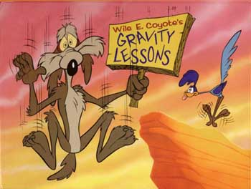
Cautionary Tale 4. Sucker for a Sales-pitch
William Tecumseh Shermanski, Principal at Cannonball Middle School,
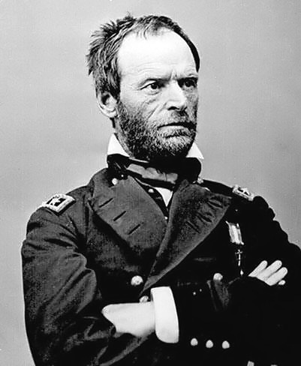
was so impressed by presentations at a conference on “Learning and the Brain” that he purchased a new program for his school---Brain Blow-out. The materials were cheap, but required lots of planning and instructional time. Totally wasted! Teachers began to see Mr. Shermanski as a poor leader.
“Gee, like we don’t have enough to do without idiotic fads!”
Despite his cool Yankee uniform, his good intentions, and his heroic namesake, Mr. Shermanski was fooled by a sales-pitch that used evocative phrases like “Brain Blow-out strengthens functions in both hemispheres,” “is research based,” “involves authentic learning,” and “is holistic and natural.” Too bad he wasn’t buying candles and incense instead of instructional materials.
Do YOU want to be INeffective?
Do you want to WASTE money, time, energy, and teachers’ trust?
Do you want people to think you’re a NINCOMPOOP?

Or a clown?
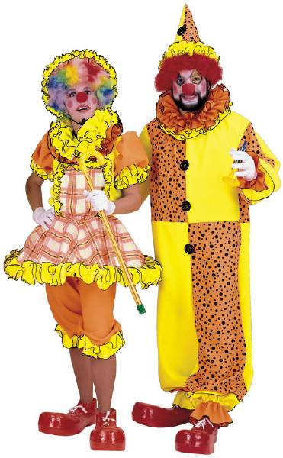
No?
WELL, IT’S GONNA HAPPEN IF YOU DON’T KNOW HOW TO THINK SCIENTIFICALLY!
Making sound educational decisions isn’t like betting on red 18 in roulette.
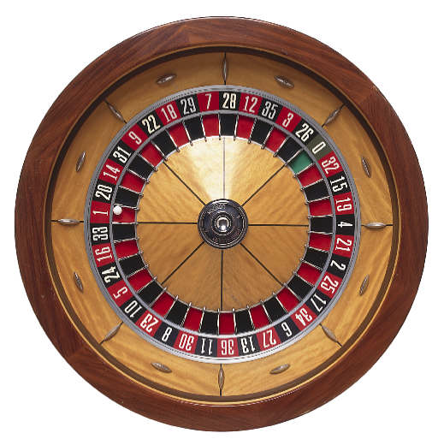
If you use guesswork to make decisions, or if you make wrong decisions because you’re not thinking clearly, you’ll have a mighty mess on your hands.
“Duuhhheeeee.”
You need to think like a laser beam cutting through metal.
Precise. Straight. Powerful.

Like a sniper aiming at a target 1000 yards away.

“Dis a piece of cakes.”
Like a…. Well, you get the point.

